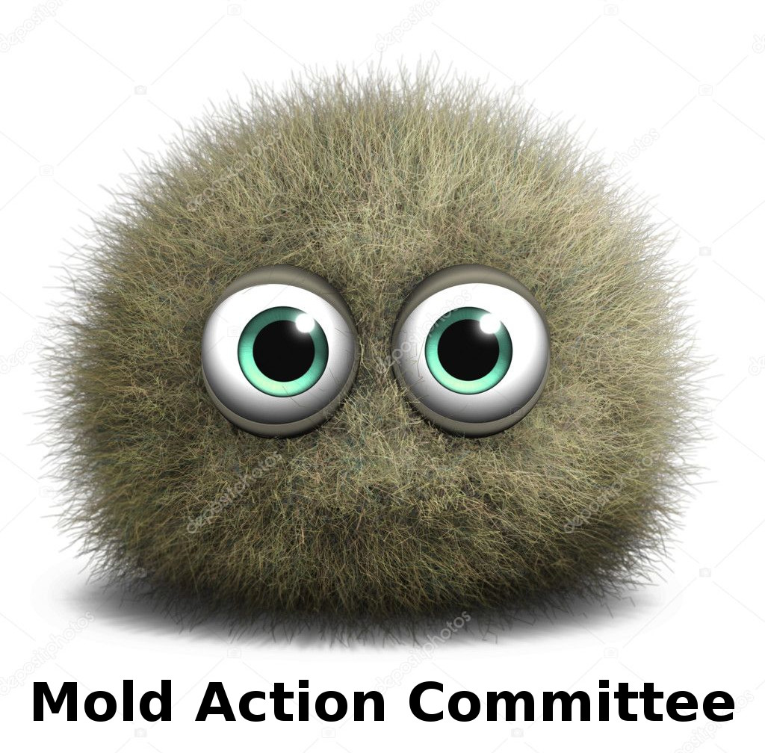

To: The Massachusetts Department of Public Health
From: Members of Arise for Social Justice, The Mold Action Committee, and Western Massachusetts Science for the People
Subject: Comments on proposed amendments to 105 CMR 410.000 – Minimum Standards of Fitness for Human Habitation (State Sanitary Code, Chapter II)
Date: 28 August 2019
We thank the Department of Public Health for its continued efforts to amend the State Sanitary Code to better protect the health of all residents of Massachusetts.
While we are pleased to see a number of improvements in the Code, we have also identified several gaps that, if not corrected, will prevent the commonwealth from effectively addressing the serious health problems posed by mold.
Positives in the Proposed Revisions:
- The criterion for establishing that a residence is unfit for habitation has shifted from mold to “dampness.” This opens greater possibilities for preventive action: damp conditions can be required to be remediated before mold has a chance to grow.
- The proposed language does not require proof of dangerous levels of mold to mandate the repair of conditions leading to dampness (see 410.620(E)(2): “Boards of health shall not be required to conduct environmental testing for mold”).
- The proposed language with its focus on dampness also protects against health effects from other dampness associated issues such as allergens from dust mites and cockroaches.
- The revisions allow for occupants to request inspections and remain anonymous; they also protect the right of occupants to request inspections even if there are eviction notices or disputes with the landlord.
Gaps in the Proposed Revisions that Must Be Addressed:
- Under 410.620(E)(2): “Any environmental test results for mold shall not constitute a violation of 105 CMR 410.000.” This is highly problematic, because high levels of mold can be present even when dampness is not detected. Positive test results for mold should be admissible as evidence that the dwelling does not constitute a clean, dry indoor space and/or that a problem exists that requires further investigation or remediation, especially when occupants are presenting with symptoms related to mold exposure.

- The term “chronic dampness” is problematic because it does not define how long dampness needs to exist to be considered “chronic” and it excludes one-time water events that, if not properly cleaned, can produce lasting mold problems. This should be changed to “dampness” to include both chronic and acute events.
- The language specifies the need to address the source (e.g., leaks) of the dampness problem, but it does not specify the need to clean up materials contaminated in the course of the water event(s). An item should be added to the list in 410. 630(A): “Failure to remediate, in accordance with EPA guidelines, following chronic dampness or a water event that resulted in the growth of mold or other fungi.”
- The language lacks specifics on how dampness will be determined. We recommend the use of a moisture meter with general guidelines for what constitutes dampness beyond acceptable levels.
Thank you for considering these points. We trust that the positives in the proposed amendments will be preserved while the gaps are properly addressed.
Sincerely,

Tatiana Cheeks
Director
Mold Action Committee
38 School St.
Springfield, MA 01105

Emma Harnisch
Member
Western Massachusetts Science for the People
11 Walnut Street
Northampton, MA 01060

Katy Pyle
Environmental Justice Organizer
Arise for Social Justice
38 School St.
Springfield, MA 01105

Christine Rogers
Aerobiology Instruction and Research LLC
87 Hillside Rd.
South Deerfield, MA 01373

Sigrid Schmalzer
Member
Western Massachusetts Science for the People
102 Williams St.
Northampton, MA 01060

Brian Schultz
Member
Western Massachusetts Science for the People
Hampshire College, School of Natural Sciences
Amherst, MA 01002

